Wonder
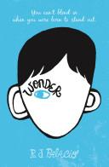
R J Palacio
RHCP, Mar 1, 2012 - Juvenile Fiction - 416 pages
50 Reviews
'My name is August. I won't describe what I look like. Whatever you're thinking, it's probably worse.'
Auggie wants to be an ordinary ten-year-old. He does ordinary things - eating ice cream, playing on his Xbox. He feelsordinary - inside. But ordinary kids don't make other ordinary kids run away screaming in playgrounds. Ordinary kids aren't stared at wherever they go.
Born with a terrible facial abnormality, Auggie has been home-schooled by his parents his whole life. Now, for the first time, he's being sent to a real school - and he's dreading it. All he wants is to be accepted - but can he convince his new classmates that he's just like them, underneath it all?
Now featuring a brand-new chapter told by bully Julian, WONDER is a funny, frank, astonishingly moving debut to read in one sitting, pass on to others, and remember long after the final page.

Attila the Hun: Leader of the Barbarian Hordes
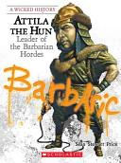
Sean Price
Scholastic Library Publishing, 2009 - Juvenile Nonfiction - 128 pages
12 Reviews
Features:
- Opening quote by or about the featured villain/villainess
- Historical map, annotated with key locations from person's life
- "A Wicked Web" featuring allies and enemies
- Historical photos and etchings
- Boxes with additional information
- Photo documentaries: six to eight pages of photos and captions telling the person's life
- Timeline, glossary, additional sources
- Engaging narrative nonfiction written at a very accessible reading level

Historical Fiction Medieval Novel Choices: Students will choose one of these novels to read.

The Midwife's Apprentice
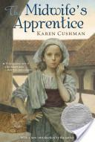
Karen Cushman
Houghton Mifflin Harcourt, 2012 - Juvenile Fiction - 122 pages
651 Reviews
From the author of Catherine, Called Birdy comes another spellbinding novel set in medieval England. The girl known only as Brat has no family, no home, and no future until she meets Jane the Midwife and becomes her apprentice. As she helps the sharp-tempered Jane deliver babies, Brat--who renames herself Alyce--gains knowledge, confidence, and the courage to want something from life: "A full belly, a contented heart, and a place in this world." Medieval village life makes a lively backdrop for the funny, poignant story of how Alyce gets what she wants. A concluding note discusses midwifery past and present. A Newbery Medal book.
Crispin: The Cross of Lead
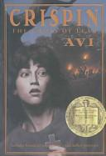
Avi
Paw Prints, Aug 11, 2008 - Juvenile Fiction - 208 pages
151 Reviews
After being accused of a crime, thirteen-year-old Crispin becomes a wanted man and so must use a new identity and keep on the run in order to stay alive, in a suspenseful middle reader set in fourteenth-century England. A Newbery Medal Book & ALA Notable Children's Book. Reprint.

Adam of the Road
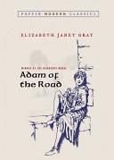
Elizabeth Janet Gray, Elizabeth Gray Vining
Puffin Books, 2006 - Juvenile Fiction - 317 pages
108 Reviews
Eleven-year-old Adam loved to travel throughout thirteenthcentury England with his father, a wandering minstrel, and his dog, Nick. But when Nick is stolen and his father disappears, Adam suddenly finds himself alone. He searches the same roads he traveled with his father, meeting various people along the way. But will Adam ever find his father and dog and end his desperate search?

A Christmas Carol
Charles Dickens
Cricket House Books LLC, Nov 20, 2009 - Fiction - 72 pages
48 Reviews
"Marley's face. It was not in impenetrable shadow as the other objects in the yard were, but had a dismal light about it, like a bad lobster in a dark cellar." Ebenezer Scrooge is unimpressed by Christmas. He has no time for festivities or goodwill toward his fellow men and is only interested in money. Then, on the night of Christmas Eve, his life is changed by a series of ghostly visitations that show him some bitter truths about his choices." "Dickens' most influential book is a funny, clever, and hugely enjoyable story.

The Samurai's Tale
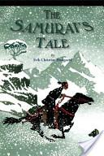
Erik Christian Haugaard
Houghton Mifflin Harcourt, 2005 - Juvenile Fiction - 234 pages
52 Reviews
When the powerful Lord Takeda’s soldiers sweep across the countryside, killing and plundering, they spare the boy Taro’s life and take him along with them. Taro becomes a servant in the household of the noble Lord Akiyama, where he meets Togan, a cook, who teaches Taro and makes his new life bearable. But when Togan is murdered, Taro’s life takes a new direction: He will become a samurai, and redeem the family legacy that has been stolen from him.

Historical Fiction: Age of Exploration. Students will choose one of the following novels to read. The True Confessions of Charlotte Doyle
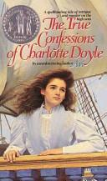
Avi
HarperCollins, Sep 2, 2003 - Juvenile Fiction - 232 pages
65 Reviews
An ocean voyage of
unimaginable consequences
Not every thirteen-year-old girl is accused of murder, brought to trial, and found guilty. But I was just such a girl, and my story is worth relating even if it did happen years ago. Be warned, however: If strong ideas and action offend you, read no more. Find another companion to share your idle hours. For my part I intend to tell the truth as I lived it.

Dead Reckoning: A Pirate Voyage with Captain Drake
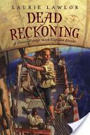
Laurie Lawlor
Simon and Schuster, 2007 - Juvenile Fiction - 322 pages
3 Reviews
The discovery of an unknown cousin is significant for anyone, but for Emmet, it's life-changing. For within moments of meeting Captain Francis Drake, Emmet is invited to be his cousin's servant aboard the Pelican on a glorious trading expedition to exotic Alexandria, Tripoli, and Constantinople. It is a chance to go on a great voyage and to escape the angry mobs who now threaten him and his home. Emmet accepts.
At sea Captain Drake's sailors become restless and angry -- animals who sniff out fear. Emmet witnesses death upon bloody death of those who are civil and kind, and sees innocent people of peace cut to shreds by men who seemed good. He realizes he must pick his friends carefully and rely on none. As the journey continues and Drake's crew pursues the fabled SilverShip, Emmet comes to see how a taste of wealth can turn men into monsters.
Award-winning author Laurie Lawlor sweeps us aboard ship with Captain Drake as we follow Emmet on an increasingly desperate journey of self-discovery while at sea with a motley crew of gold-thirsty men.

Stowaway
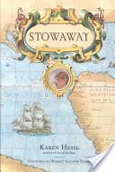
Karen Hesse
Simon and Schuster, Nov 1, 2000 - Juvenile Fiction - 319 pages
71 Reviews
In the summer of 1768, an eleven-year-old butcher's apprentice named Nicholas Young climbed aboard a ship, hid himself from captain and crew, and waited to be carried far away from the life he hated in London.
Nick didn't know it, but the ship he chose -- H.M.S. Endeavour -- was bound for an astonishing adventure. Captained by James Cook, Endeavour was on a secret mission to discover an unknown continent at the bottom of the globe. During his three-year voyage, Nick encountered hardship and was awed by new discoveries; he weathered danger and proved himself brave when disaster struck; he earned the respect and trust of the gentlemen on board; he made a friend for life. And he made history.
An eleven-year-old boy named Nicholas Young really did stow away on Cook's Endeavour. Based on exhaustive historical research and illustrated with evocative drawings by Robert Andrew Parker, Stowaway is Newbery winner Karen Hesse's extraordinary fictional account of the real Nicholas's journey.

