8th Grade Content Novels

Revolutionary War:
Woods Runner by Gary Paulsen
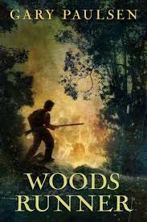

The Notorious Benedict Arnold
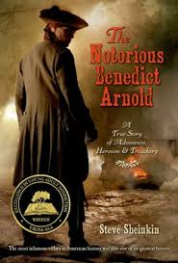

American Classic:
The Adventures of Tom Sawyer
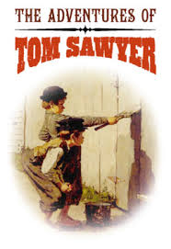
Civil War:
Mostly True Adventures of Homer P Figg
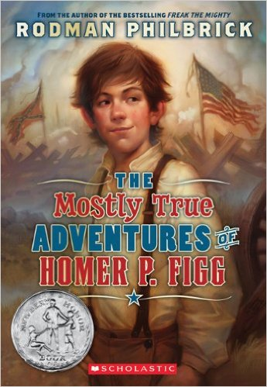

Slavery:
Elijah of Buxton
